**Name(s):**___________________________________________________________________________________________

**Fill in all sections**

**Student Learning Objectives**

Students should be able to;

1. explain why a packed bed becomes fluidized

2. explain the different contributions to pressure drop in the packed bed

3. explain the meaning of the minimum fluidization velocity

4. compute the pressure drop (ΔP) across the bed

**Fluidized Bed Desktop Learning Module (DLM) Schematic and Properties**

Fluid out

Fluid out

Fluid out

Fluid in

Fluid in

Fluid in

Re-packed Fluidized bed

Fluidized bed

Packed bed

|  |  |  |  |  |  |  |  |
| --- | --- | --- | --- | --- | --- | --- | --- |
| **Table 1:** Properties of the fluidized bed DLM | | | | | | | |
| **Properties** | | | | | | | |
| **Column properties** | | **Particle properties** | | **Bed properties** | | **Fluid properties** | |
| Dcol | 0.016 m | Dp | 0.00107 m | eM | 0.45 | r | 997 kg/m3 |
| Lcol | 0.15 m | rp | 2400 kg/m3 | LM | 0.05 m | µ | 0.001 Pa.s |

**Experiments with Fluidized Bed DLM**

**Before the Fluidized Bed DLM Experiments**

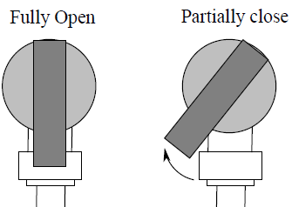

Fully Open Partially Closed Fully Closed

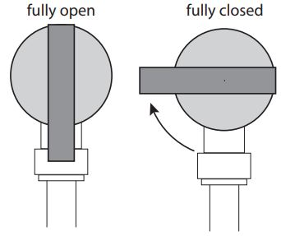

**Pump Valve Adjustment**

YouTube video instructions:

1. Assemble the pump to the inlet of the fluidized bed DLM if not assembled already.
2. Assemble the outlet tubing to the top of the column if not assembled already.
3. Make sure the pump is switched off and insert the battery.
4. Fill the beaker with water and place the pump into the beaker.
5. Make sure that the outlet tube is dipped in the beaker filled with water.
6. Watch the manometer tubes to prevent water spills before you switch on the pump in the next step.
7. Keep the pump valve fully closed and switch on the pump
8. Slowly adjust the pump valve until the column is fully filled with water with no spills.
9. Tap the column gently to get rid of the air bubbles inside the column.
10. Once you complete the setup (no air bubbles trapped and water flow with no spills) switch off the pump.
11. Make sure that the water level in the manometer tubes are equal once you are complete with the steps above.

**Experiment 1:** Flow rate, pressure drop and bed height

**Packed bed**

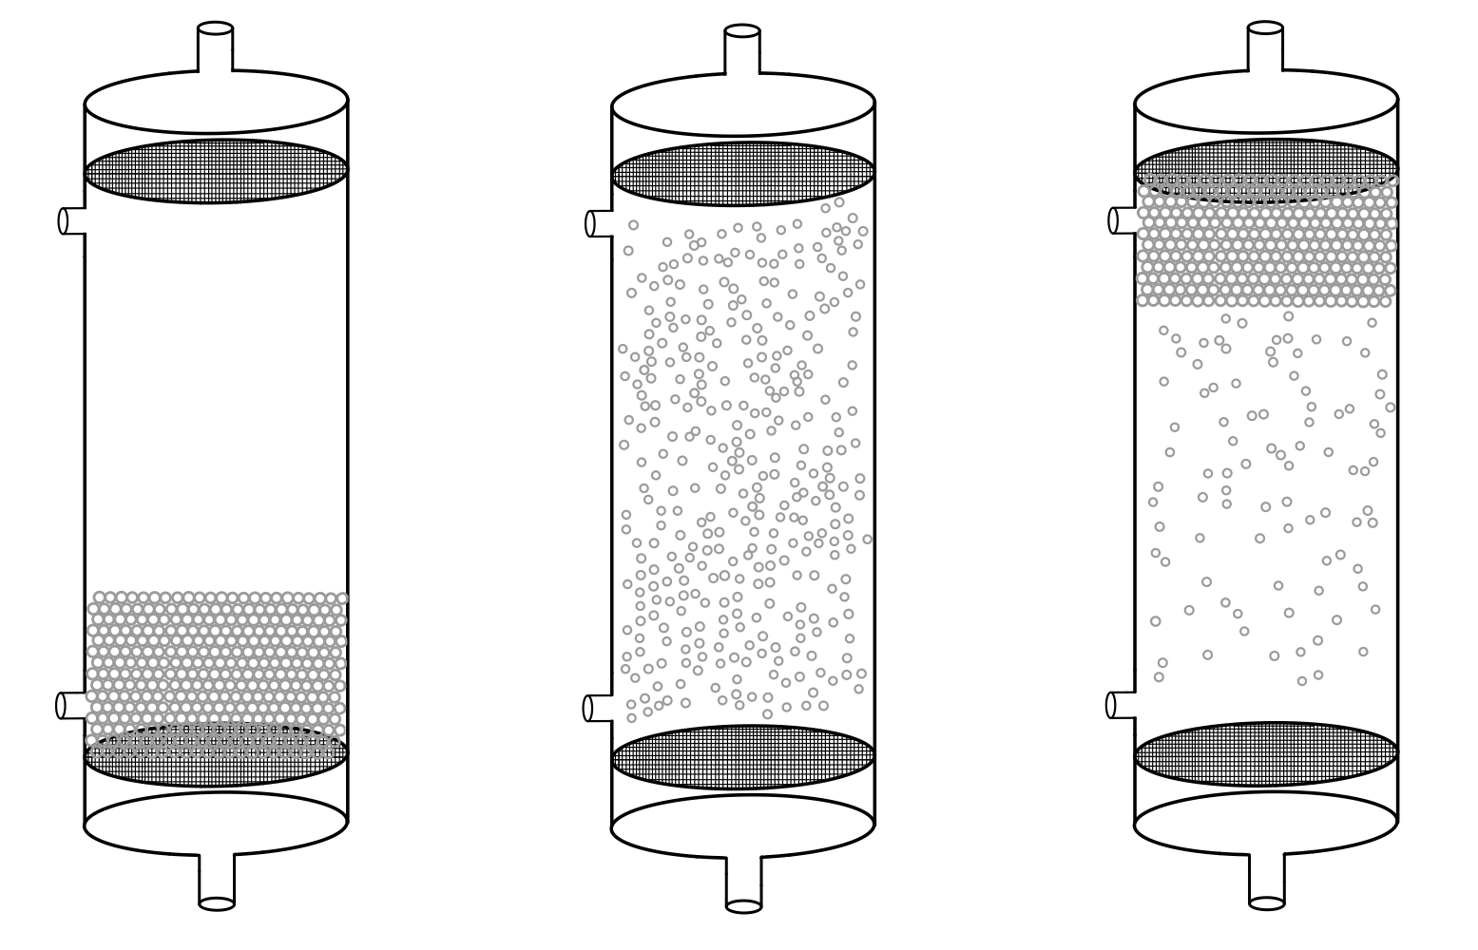

Fluid out

**Packed Bed**

1. Keep the pump valve fully closed and switch on the pump.
2. Adjust the pump valve slowly to increase the flow rate but make sure that particles are not moving.
3. If you see a difference between the left and right manometer tubes, this indicates that the water is flowing.
4. Carefully observe the difference between left and right manometer tubes as you adjust the pump valve slowly.
5. If you suddenly make the particles move, switch off the pump and repeat the steps above.

Observe the difference between the left and right manometer tubes as you increase the flow rate but make sure that the particles remain stationary. Write down your observations in a few words and show with arrows down below.

Fluid in

$$V_{0}$$

$V_{0}$ $ΔP ________$

________

**Fluidized Bed**

**Fluidized bed**



Fluid out



1. Reset the DLM by switching off the pump.
2. Before you start, make sure that the water level in the manometer tubes are equal.
3. Keep the valve fully closed and switch on the pump.
4. Slowly adjust the pump valve until the particles start moving.
5. Carefully observe the difference left and right manometer tubes as you adjust the pump valve slowly.
6. Observe the bed height as you adjust the pump valve slowly.
7. Do not allow the bed to expand all the way to the top of the column, as you increase the flow rate.

Observe the difference between the left and right manometer tubes and the bed height as you increase the flow rate when the bed is fluidized. Write down your observations in a few words and show with arrows down below.

Fluid in

$$V_{0}$$

$V_{0}$ $ΔP ________$ $L ________$

________

**Re-packed Fluidized Bed**

Fluid out

**Fluidized bed**



Scan the QR code for the demonstration.



**Re-packed Fluidized Bed**

Fluid in

$$V_{0}$$

**Prediction of the Pressure Drop and the Bed Height**

Fluid out

Fluid out

Fluid out

**Fluidized bed**

**Packed bed**

Fluid in

Fluid in

Fluid in

**Re-packed Fluidized bed**

The regions 1, 2 and 3 in the plots correspond to the diagrams.

According to your observations, on the water levels in manometer tubes, plot the pressure drop trends below as you increase the flow rate.

Plot the bed height trends below as you increase the flow rate.

ΔP

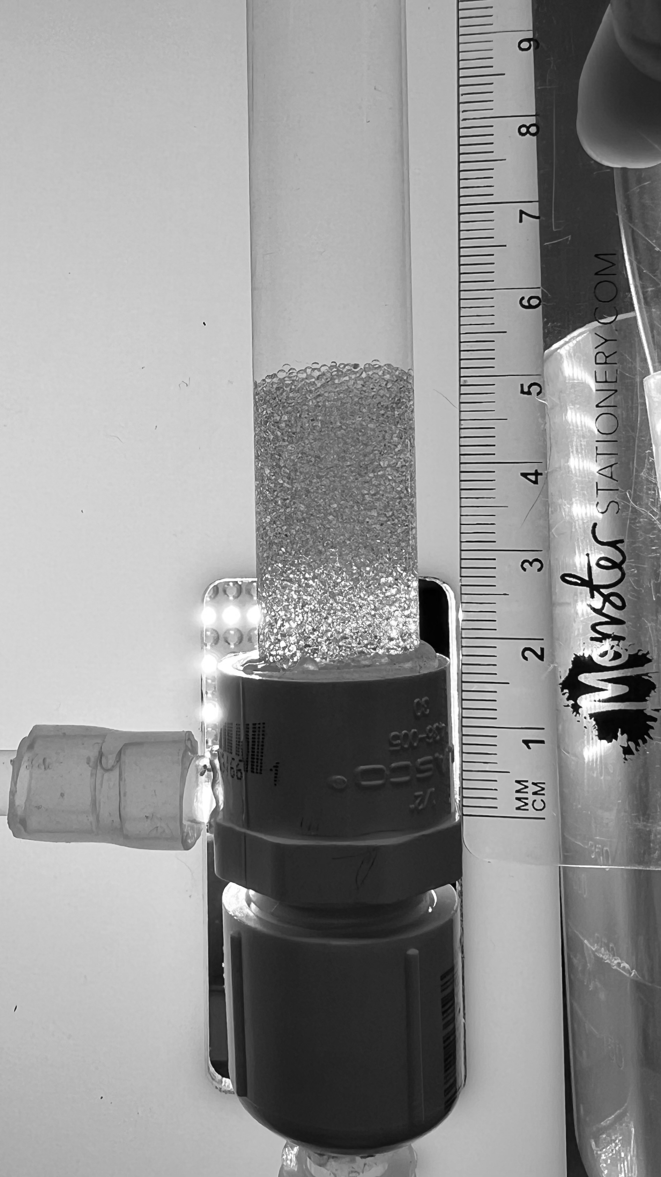**Experiment 2:** Minimum fluidization velocity and particle Reynolds Number

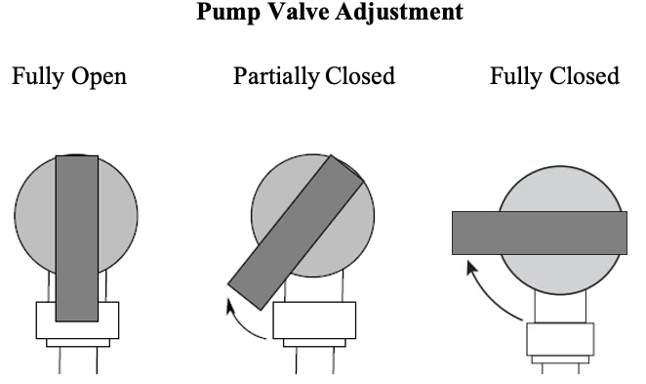

1. Reset the DLM by switching off the pump.
2. Before you start, make sure that the water level in the manometer tubes are equal.
3. Keep the valve fully closed and switch on the pump.
4. Slowly adjust the pump valve where the bed is initially fluidized.
5. Measure the flow rate by filling the empty beaker until 200mL and use a stopwatch to record the time.

According to what you read on the right and left manometer tubes, fill out the table below.

|  |  |  |  |  |
| --- | --- | --- | --- | --- |
| Minimum fluidization flow rate (mL/s) | $$H_{L} (cmH_{2}O)$$ | $$H_{R} (cmH_{2}O)$$ | $$ΔP=H_{L}- H_{R}$$ $$(cmH_{2}O)$$ | L (cm) |
|  |  |  |  |  |

Adjust the pump and increase the bed height from the point where the bed is initially fluidized. According to what you read on the right and left manometer tubes, fill out the table below for two data points.

|  |  |  |  |  |
| --- | --- | --- | --- | --- |
| Flow rate (mL/s) | $$H_{L} (cmH_{2}O)$$ | $$H_{R} (cmH_{2}O)$$ | $$ΔP=H_{L}- H_{R}$$ $$(cmH_{2}O)$$ | L (cm) |
|  |  |  |  |  |
|  |  |  |  |  |

Discuss what you found differently for $ΔP$ values in a few words.

**Homework Problems**

1. In Experiment 1, explain what happened in the column as you increase the pump.
2. Explain what is happening physically when the bed begins to fluidize. Draw the free body diagram of one particle.
3. Fluidization begins when;

Pressure drop across bed = Weight of the bed per unit area – Buoyant force of the bed per unit area

|  |  |
| --- | --- |
| $$ΔP = g\left(1-ε\right)\left(ρ_{p}\right)L - g\left(1-ε\right)\left(ρ\right)L$$ | (1) |

$$( ρ=ρ_{fluid})$$

For the initial fluidization, $ε$ is the minimum porosity, $ε_{M}$, then pressure drop across the bed becomes;

|  |  |
| --- | --- |
| $$\frac{ΔP}{L}=g\left(1-ε_{M}\right)\left(ρ_{p}-ρ\right)$$ | (2) |

Combine the Ergun equation (4) for $ε_{M }and V_{0M}$;

|  |  |
| --- | --- |
| $$\frac{ΔP}{L}=\frac{150V_{0M}μ}{{Φ_{s}}^{2}{D_{p}}^{2}}\frac{{(1-ε_{M})}^{2}}{{ε_{M}}^{3}}+\frac{1.75ρ{V_{0M}}^{2}}{Φ_{s}D_{p}}\frac{(1-ε_{M})}{{ε_{M}}^{3}}$$ | (3) |

Set the right-hand sides of Eqs. 2 and 3 equal to each other and simplify to give a quadratic equation for the minimum fluidization velocity.

If the Re*p* < 1, the kinetic loss term can be neglected. Simplify the quadratic equation for this case.

Solve this equation for the minimum fluidization velocity, $V_{0M}$, for the low Reynolds number case.

If the Re*p* > 1000, the viscous loss term can be neglected. Simplify the quadratic equation for this case.

Solve this equation for the minimum fluidization velocity, $V_{0M}$, for the high Reynolds number case.

1. In Experiment 2, the minimum fluidization flow rate (mL/min) was found;
2. From your data, find $V_{0M}$ and Re*p*. Use Table 1 (pg. 1) for additional information.
3. Depending on the Re*p* you found experimentally, determine which equations derived in Question 3 should be used to predict $V_{0M}$. Use that equation to calculate $V_{0M}$.
4. Compare your experimental and predicted values and find % error.

$$\% Error=\frac{(experimental value-predicted value)}{(predicted value)} x 100\%$$

|  |  |  |
| --- | --- | --- |
|  | $V_{0M}$ (m/s) | Re*p* |
| Experimental values |  |  |
| Predicted values |  |  |

1. In Experiment 2, you measured the pressure drop, $ΔP,$ across the bed at the point of minimum fluidization. Use the Ergun equation (Eq. 3) to predict the $ΔP$ across the bed for the experimental $V_{0M}$ and compare to the measured $ΔP$. Find the % error according to the expression from Question 5.

(1 $cmH_{2}O$ = 98.0665 Pa)

|  |  |
| --- | --- |
|  | $ΔP$ (Pa) |
| Experimental values |  |
| Predicted values |  |

1. Give a few examples of practical applications of fluidized beds.